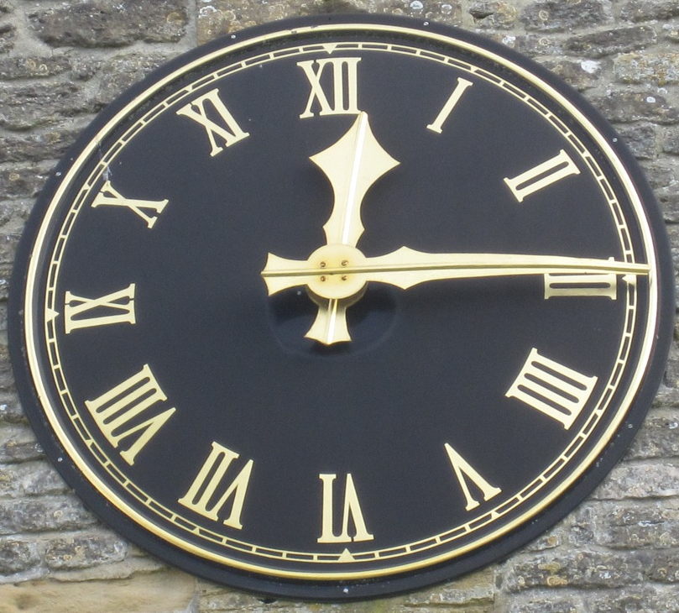
Kirkburton Parish COUNCIL

CLOCK grants
Application FORM 2025 - 26

This form is only valid for applications to be considered in November 2024.

If completing this form by hand, please use black ink and block capitals.

I would like to apply for an Annual Clock Maintenance Grant.

Organisation Details

Name of Organisation:

Address of Organisation:

Please return the completed form to Mrs Angela Royle either by post or email to: admin@kbpc.co.uk by Friday 25 October 2024. Any applications received after that date will automatically be refused.
Please do not use recorded delivery.
The outcome of all applications will be published in the November set of the Grants & CP Committee minutes, which will be uploaded to the website in December. http://www.kbpc.co.uk/Minutes.aspx The funding will be paid out in April 2025.
Rules:
- The application must be received by the Council by the deadline, or it will be automatically refused.
- The clock must not be in private ownership, but may be owned by a Limited Company which provides community facilities.
- The clock must be visible to members of the public from a highway.
- At the time of application the clock must be in working order.
All data contained in the form will be processed in accordance with the General Data Protection Regulations. Please visit http://www.kbpc.co.uk/Documents/6/privacy-notice.aspx to view the Council’s Privacy Notice.

PLEASE NOTE: No supplementary information is required to apply for a Clock Grant.
- Have you fully completed both pages of the application form?
- Applications received after the closing date will not be accepted.
- Please type CLOCK GRANT in the subject line.
- All emailed applications will be acknowledged. If you do not receive an acknowledgement, it may not have been received.
If you are printing this form at home, please ensure this page is on a separate sheet, as the information will be separated from your application form in order to comply with GDPR.

CONTACT DETAILS

- Name of organisation:
- Contact person for this application: Mr/Rev/Mrs/Miss/Ms * Other Title:

- Position held (e.g. Chairman, Secretary, Trustee etc):
- Address where the organisation is based:

NB: This must fall within the Parish Council area.
- Correspondence address (if different to the one above):

- Email address: Daytime Tel No:

Please type CLOCK GRANT in the subject line of the email.
- Account Name:

Type of Account:

Sort Code: Account No:

Please ensure that the name is exactly as on the statement, or the transfer cannot be made.

Have these details changed from those previously supplied? Yes / No
The Parish Council does not retain groups’ bank details, but if you have changed accounts since you last supplied your details, the Parish Council will need to register you again with the bank to make the payment.

I confirm
- that the clock is not in private ownership / is owned by a limited company which provides community facilities.
- that the clock is visible by members of the public from a highway.
- that the clock is in full working order at the time of this application.
- that the information contained in this application is correct.
- I am authorised to make the application on behalf of the organisation.
Signed: Date:

